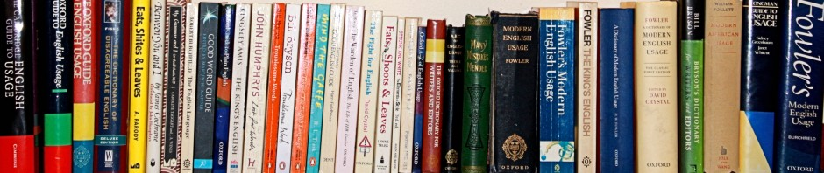

Symposium Life after HUGE? – programme

Leiden University Centre for Linguistics, 9 December 2016

Place: Academy Building, “Klein Auditorium”, Rapenburg 73, Leiden (1st floor)

9.00−9.30 | Welcome
9.30−9.45 | Opening by Ingrid Tieken-Boon van Ostade
9.45−10.30 | Robin Straaijer |  | Following Fowler: A birds-eye view of the most influential English usage guide
10.30−11.15 | Oliver Kamm |  | Prescriptive Grammar: The Quest for Correctness
11.15−11.45 | Coffee break
11.45−12.30 | Rebecca Gowers |  | Another One?
12.30−12.45 | Adrian Stenton |  | A Survey on Attitudes to the Species Noun Phrase
12.45−13.45 | Lunch
13.45−14.30 | Harry Ritchie |  | The Fearful Backwardness of the Natives
14.30−15.00 | Lyda Fens-de Zeeuw |  | The HUGE presence of Lindley Murray
15.00−15.30 | Tea break
15.30−15.50 | Carmen Ebner |  | Proper English Usage? Insights into an endeavour to bridge the unbridgeable
15.50−16.10 | Viktorija Kostadinova |  | Studying Language Prescriptivism
16.10−16.30 | Morana Lukač |  | Grassroots Prescriptivism: An analysis of individual speakers’ efforts in maintaining the standard language ideology
16.30−17.00 | Ingrid Tieken-Boon van Ostade |  | The Bridging the Unbridgeable blog: Building an online research network
17.00−18.00 | Drinks


